**Instance method program**

**1.print name and age**

class Test1

{

public void displayName(String name)

{

System.out.println("my name is: " +name);

}

public int displayAge(int age)

{

System.out.println("age is: " +age);

return age;

}

public static void main(String args[])

{

Test1 t=new Test1();

t.displayName("Abhilasha");

t.displayAge(27);

}

}

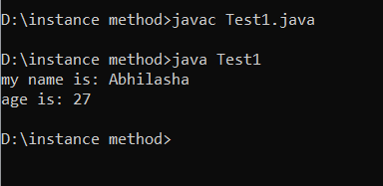

**2.factorial**

import java.util.Scanner;

class Factorial

{

public int fact(int fact)

{

System.out.println("the factorial of number is: " +fact);

return fact;

}

public static void main(String args[])

{

Scanner s=new Scanner(System.in);

System.out.println("enter the number");

int a=s.nextInt();

int fact=1;

for(int i=1; i<=a; i++)

{

fact=fact*i;

}

Factorial t1=new Factorial();

t1.fact(fact);

}

}

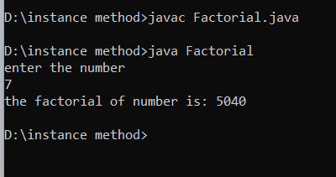

**3.palindrome/not**

import java.util.Scanner;

class Palindrome2

{

public int reverse(int temp)

{

System.out.println("the reverse number is: " +temp);

return temp;

}

public int palindrome(int reverse)

{

System.out.println("the given number is palindrome" +reverse);

return reverse;

}

public static void main(String args[])

{

int remainder=0;

int reverse=0;

Scanner r=new Scanner(System.in);

System.out.println("enter the number");

int num=r.nextInt();

int temp=num;

while(num>0)

{

remainder=num%10;

reverse=(reverse*10)+remainder;

num=num/10;

}

if(temp==reverse)

{

System.out.println("palindrome number");

}

else

{

System.out.println("not a palindrome number");

}

Palindrome2 p=new Palindrome2();

p.reverse(temp);

p.palindrome(reverse);

}

}

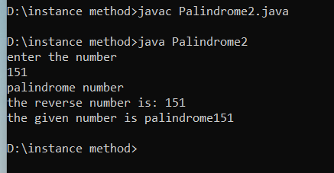

**4.candidate voting**

import java.util.Scanner;

class Voting2

{

public int voting(int age)

{

System.out.println("the candidate is eligible for voting" + " " +age);

return age;

}

public static void main(String args[])

{

Scanner r=new Scanner(System.in);

System.out.println("enter the age of candidates");

int age=r.nextInt();

if(age>=18)

{

boolean b=true;

System.out.println("eligible for voting" + " " +b);

}

else

{

boolean c=false;

System.out.println("not eligible for voting" + " " +c);

}

Voting2 s=new Voting2();

s.voting(age);

}

}

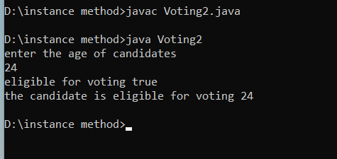

**5.bank account**

class Bank2

{

int currentbal=25000,withdraw=15000;

int newbal,deposit=5000;

public static void main(String args[])

{

Bank2 s=new Bank2();

s.accountDetails();

s.currentBalance();

}

public void accountDetails()

{

newbal=currentbal+deposit;

System.out.println("newbal is : " +newbal);

if(newbal>=withdraw)

{

System.out.println("transaction being processed");

}

else

{

System.out.println("sorry no sufficient amount");

}

}

public void currentBalance()

{

int newcurrentbal=newbal-withdraw;

System.out.println("Balance amount is : " +newcurrentbal);

}

}

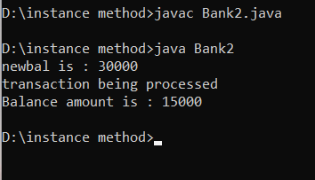

**6.discount**

class Discount2

{

public int amount(int ironbox, int fridge)

{

int totalamount=ironbox+fridge;

return (totalamount);

}

public void discount(int amount)

{

if(amount>5000)

{

float discount1=(amount*0.2f);

System.out.println("the discount is : " +discount1);

}

else

{

System.out.println("no discount");

}

}

public static void main(String args[])

{

Discount2 d=new Discount2();

System.out.println("the total amount is : " +d.amount(1500,15000));

d.discount(6000);

}

}

